1. CREATE A TABLE IN SE11

1. CREATE THE STRUCTRE FOR WHICH FIELDS TO BE UPDATED FROM GATEWAY.

1. Goto segw and create a project for odata service

1. Open the Project and click on DataModel->Import->DDICStructure.

1. Give entity Name and Import the DDIC Structure. And click on next and save.

6 Select the fields to which CRUDQ operations have to be performed.

7.Select the Key Fields and click on finish.

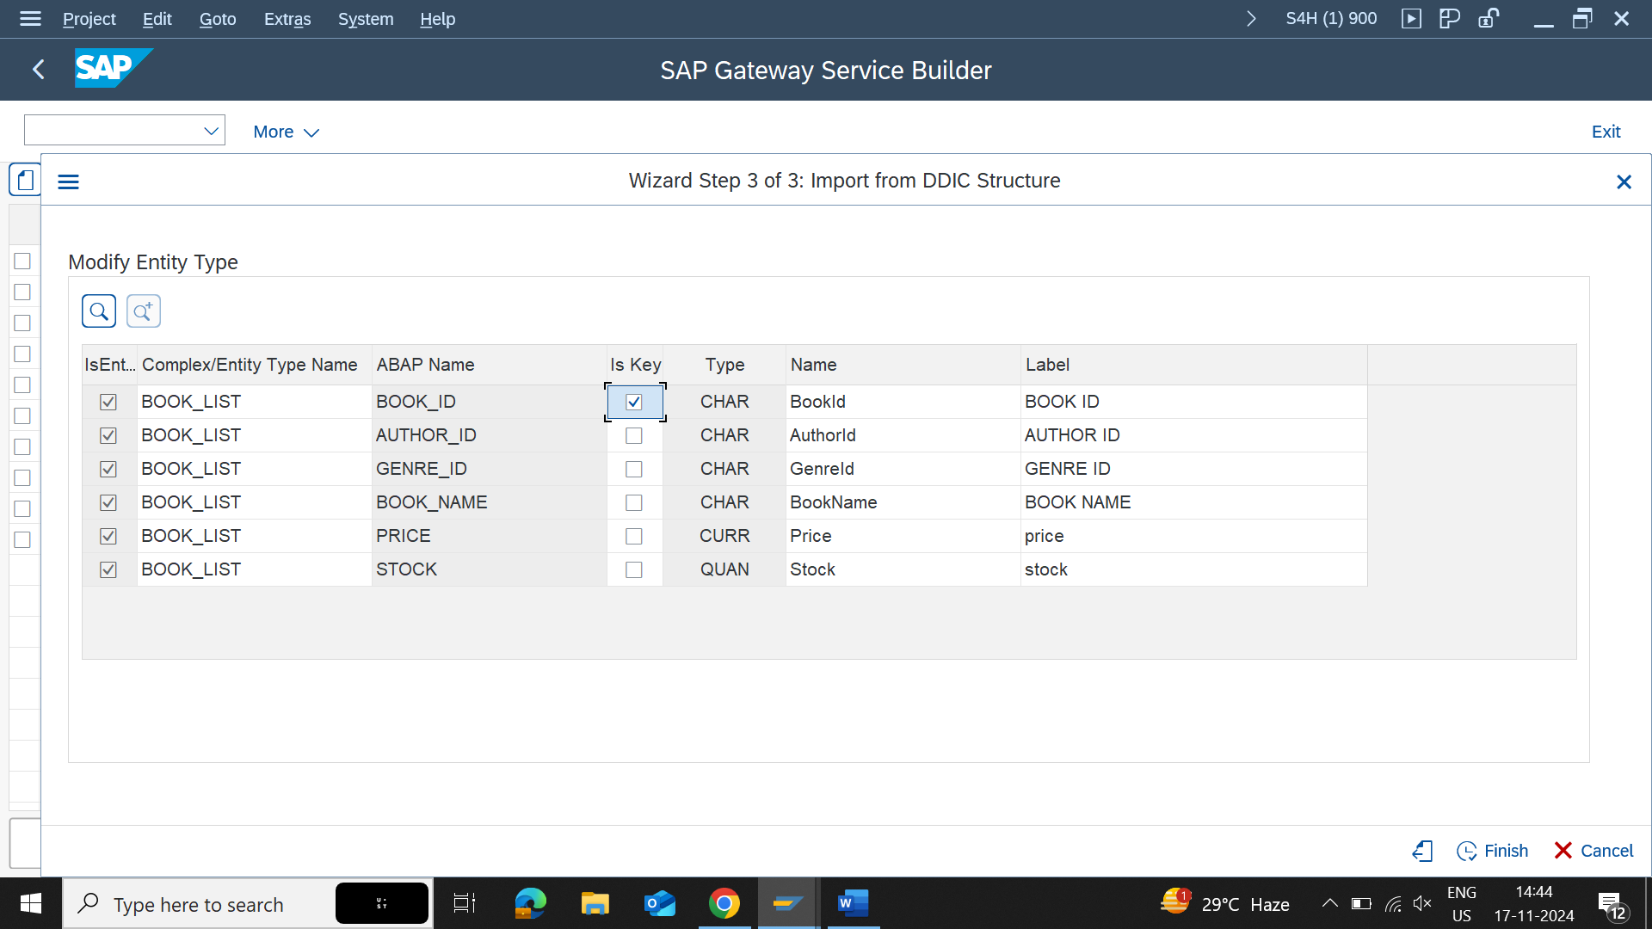

8. Genrate the runtime object.

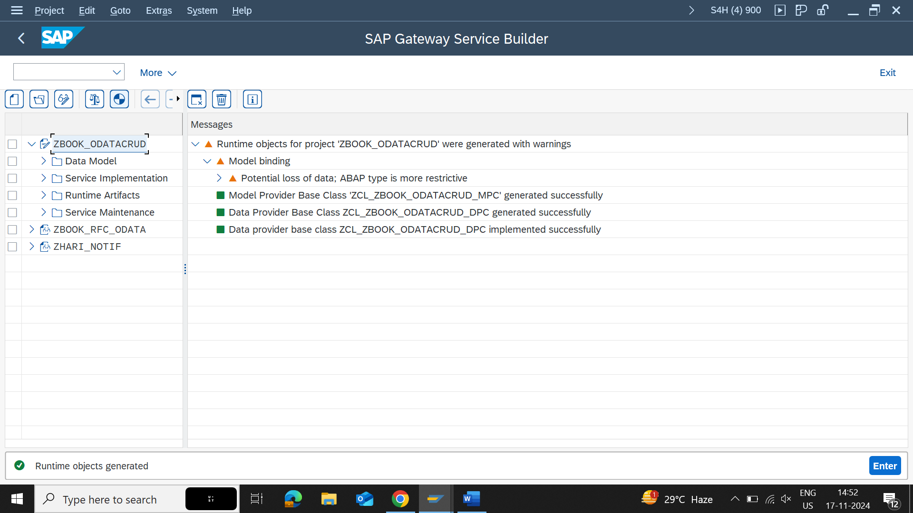

9. Now go to Runtime Artifacts and click on zcl_zbook_odatacrud_dpc_ext .

10. click on methods -> implementations -> choose the metgod and right click on to redefine and redefine the methods to implement the logic the for create , update, getEntity, getEntitySet, delete methods.

11. Logic for GetEntitySet is :

12. Logic for GetEntity is

13. Logic for create entity is

14. Logic for update entity is

15. logic for for delete entity is

16 Now go to /IWFND/MAINT_SERVICE transaction to register the project for service consumption by clicking on ADD SERVICE button

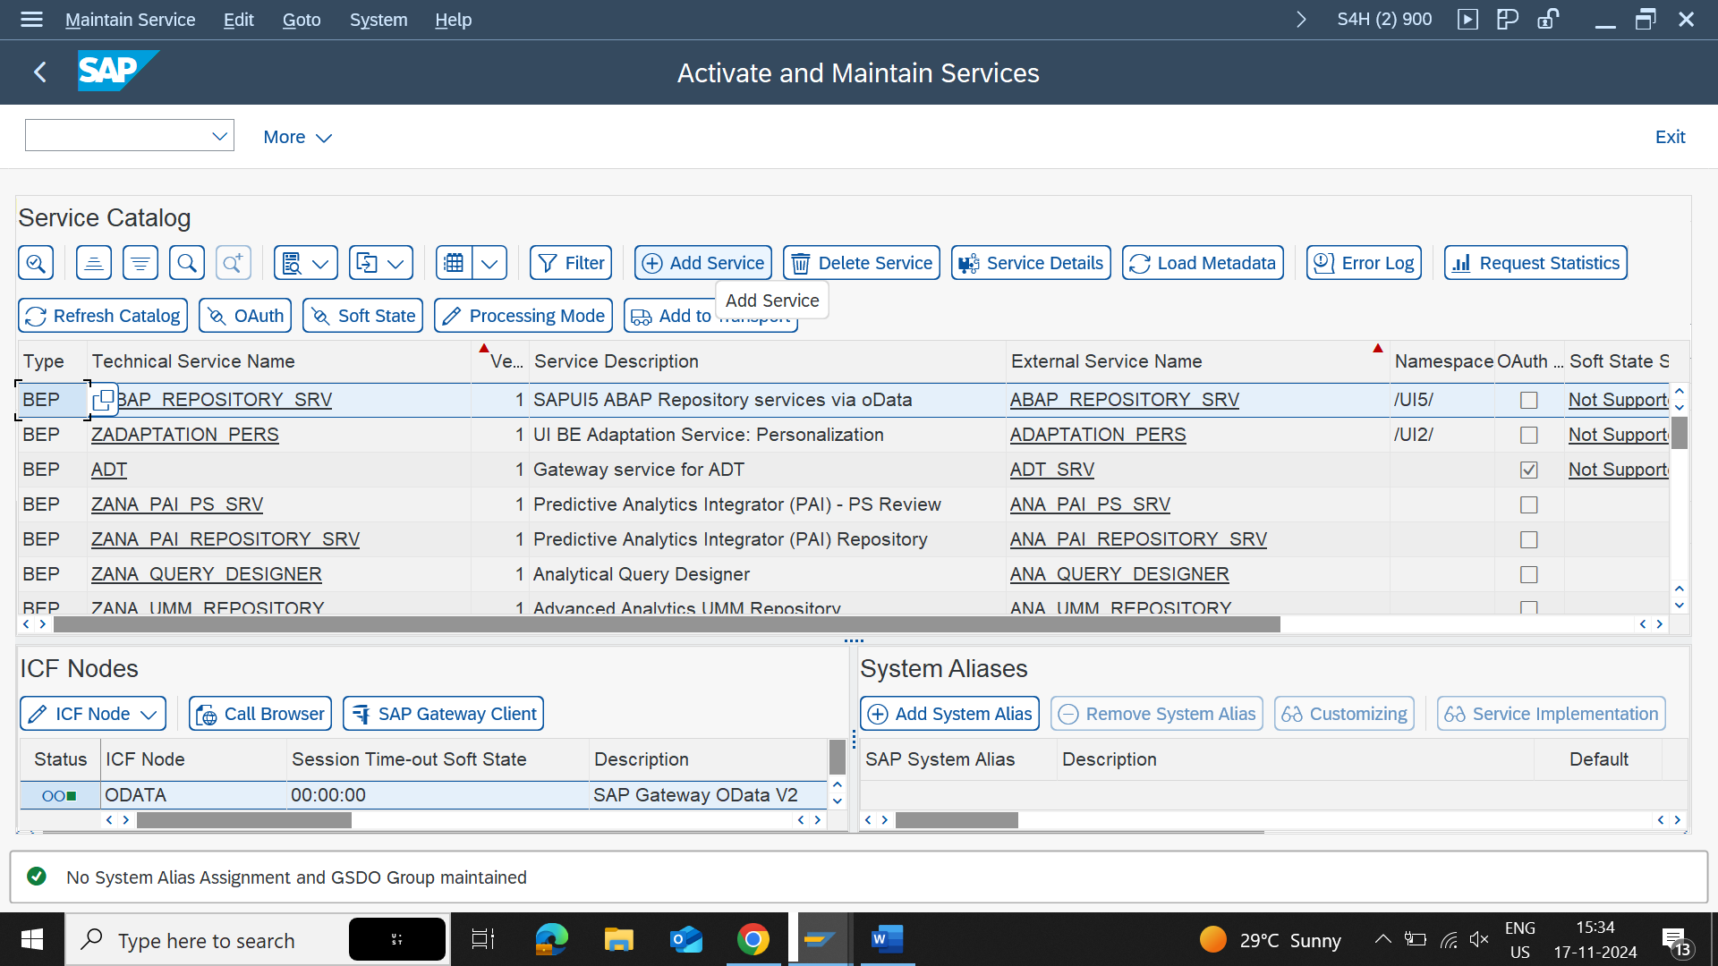

17. Give the system Alias to LOCAL and Technical Service Name of generated Object and save the details.

18. click on search button and search the service name.

19. click on ICF Node -> Configure (SICF).

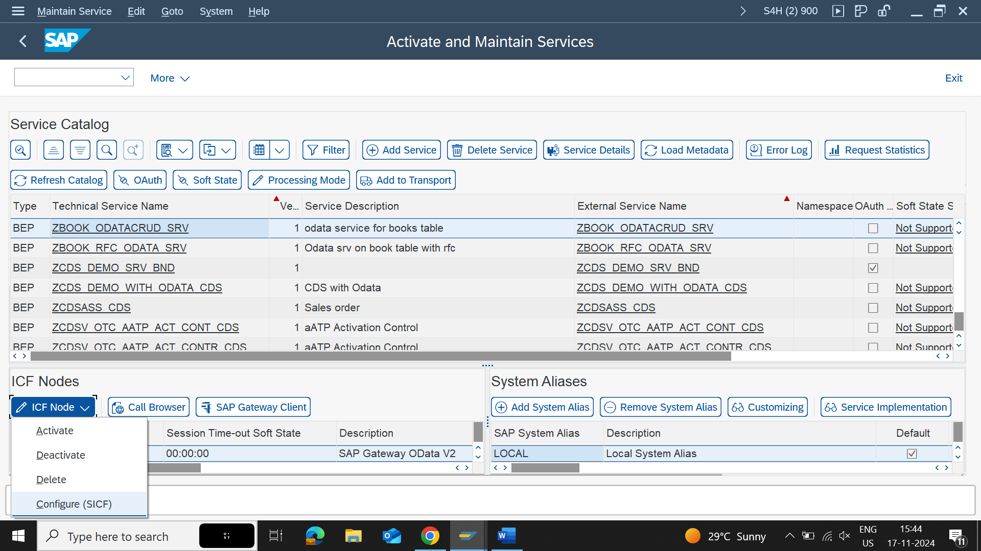

20. Click on Technical Service name and click on GUI Configuration and Give ~check_csrf_token=0 and save it.

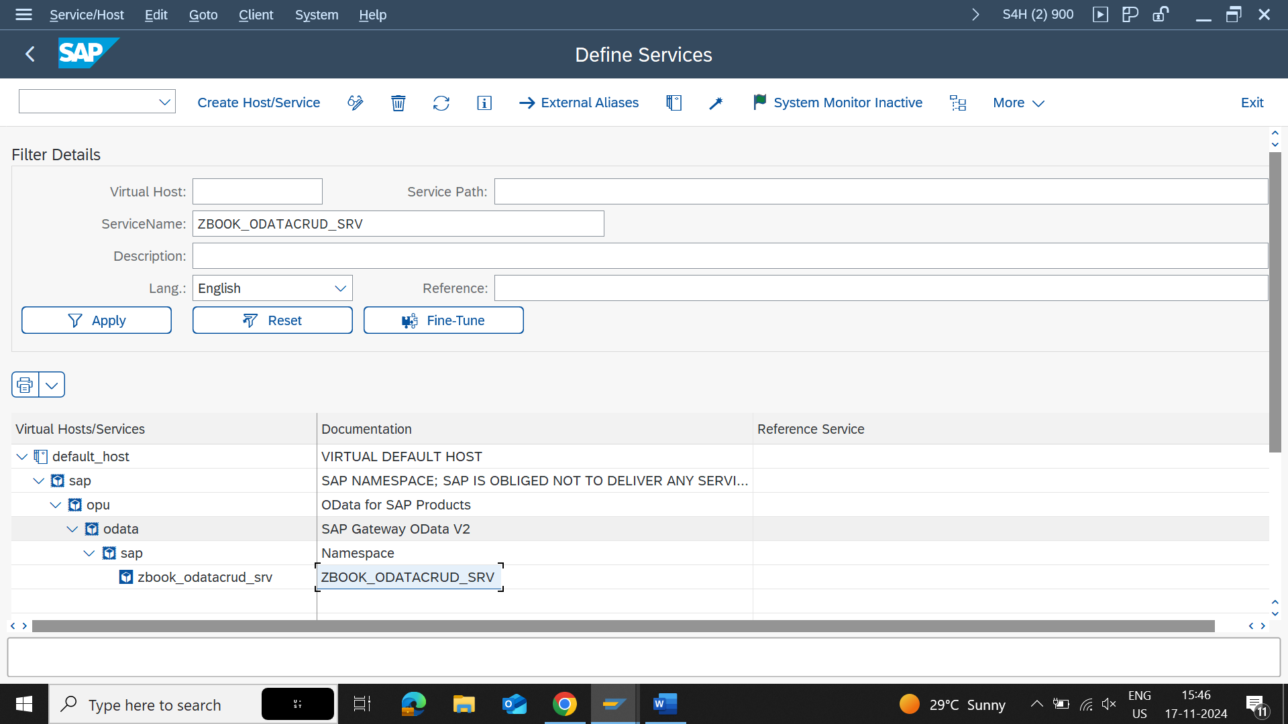

21. Go Back and Click on SAP GATEWAY CLIENT and test the service for CRUDQ operations

GET ENTITYSET :

GET ENTITY :

Delete :

Create Entity :

To Create Entity Give Content Type JSON and Pass the data.

{  
    "BookId" : "13",  
    "AuthorId" : "4",  
    "GenreId" : "4",  
    "BookName" : "Power Of Mind",  
    "Price" : "233.000",  
    "Stock" : "99"  
}

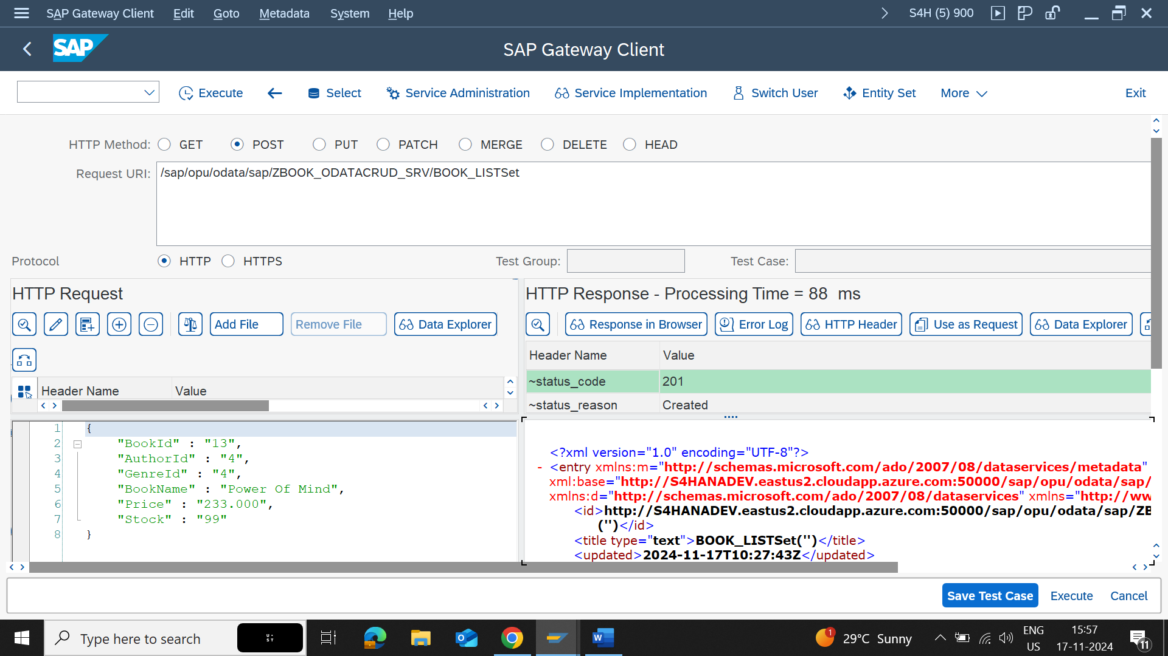

Update Entity :

